Data Flow with ORM stack

Contents

1. Introduction 3
2. Workflow diagram to deploy the stack 3
3. Create stack for Data Flow 4
4. Plan the Job 7
5. Apply the Job 8
6. Verify in the Console 9
7. Destroy the stack 10

Introduction

Oracle Cloud Infrastructure (OCI) Data Flow is a fully managed Apache Spark service that performs processing tasks on extremely large datasets without infrastructure to deploy or manage. Developers can also use Spark Streaming to perform cloud ETL on their continuously produced streaming data. This enables rapid application delivery because developers can focus on app development.
This resource provides the Application resource in Oracle Cloud Infrastructure Data Flow service.

Workflow diagram to deploy the stack

Below diagram shows how the Terraform Artifact are applied in the OCI. While creating a ORM stack, using terraform deliverables Init, Plan and Apply is the flow to provision the resource in the OCI. We can have the deliverables in any of below.

- GitLab/GitHub Repo
- Bitbucket
- Can be in folder/.zip in the local disk
- Object Storage Bucket
- Can be in compartment
- Oracle provided Template

Prerequisites:
- create user groups and policies in your tenancy
- Two Object Storage buckets(both .py and .csv files to be uploaded in buckets.)
- Sample Python Application with OCI Data Flow (https://oracle.github.io/learning-library/oci-library/oci-hol/oci-dataflow-sampleapp/workshops/livelabs/)

Create stack for Data Flow

Go to OCI Console Developer Services Resource Manager Stacks select the compartment Create Stack

My Configuration Folder Browse Select the “Data_Flow” folder that contains the terraform Upload

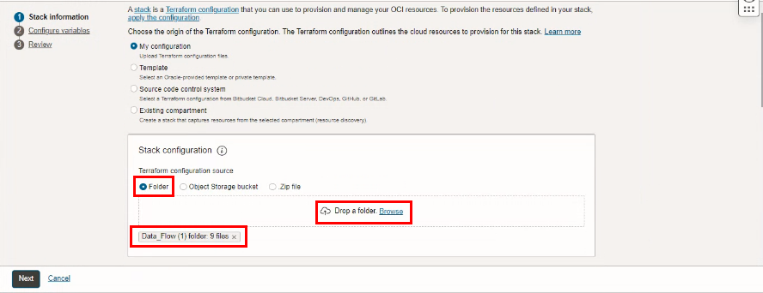

Select the parameters as per the below screen,
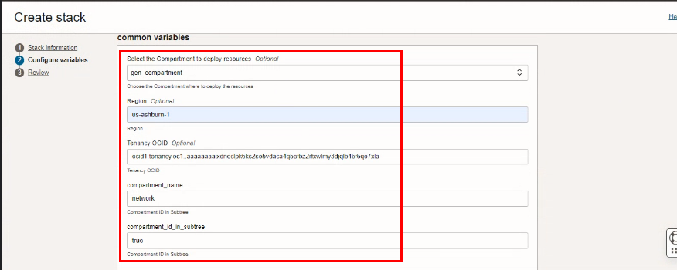

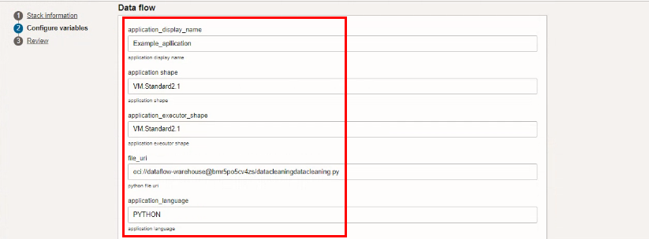

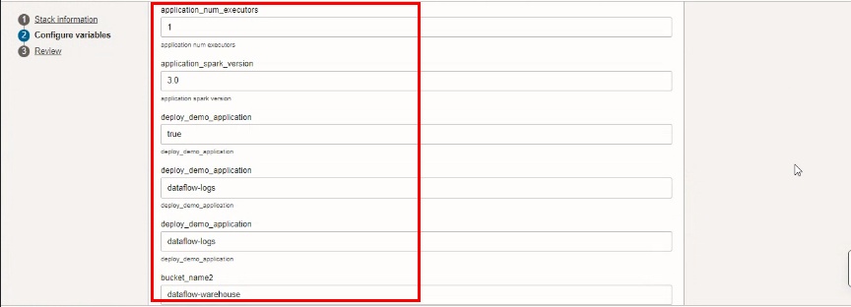
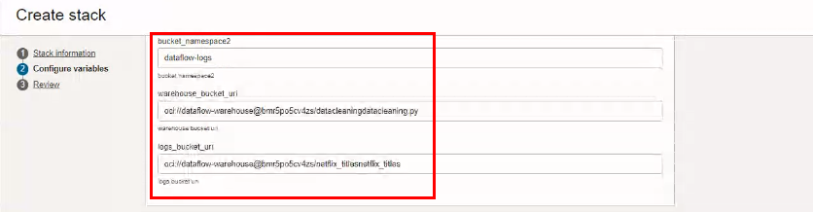
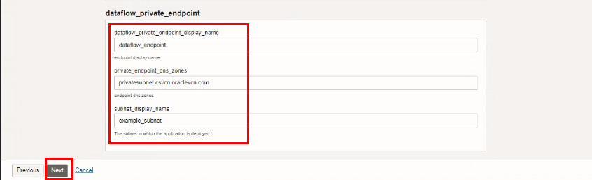
Click “NEXT”

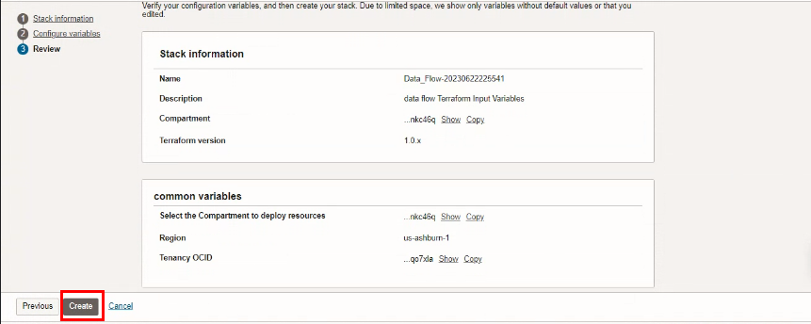
Click “CREATE”

Plan the Job

Click the “Plan”
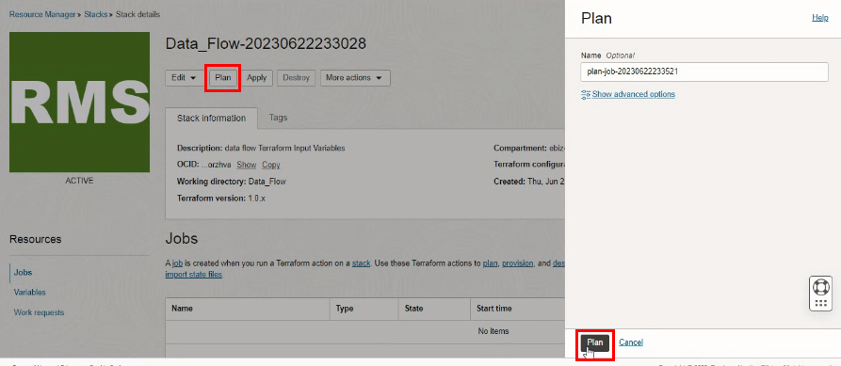

Verify the Plan is successful.
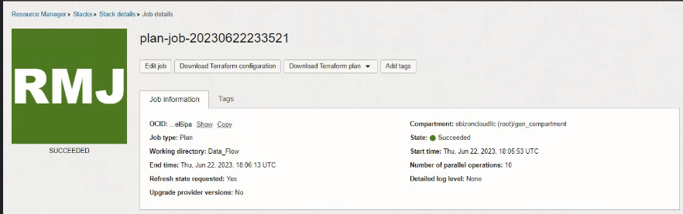

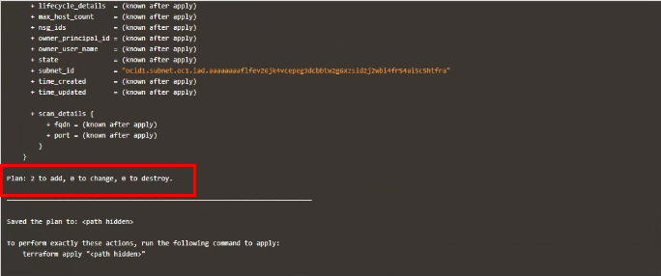

Apply the Job

Once the “plan” is success, now click “Apply”
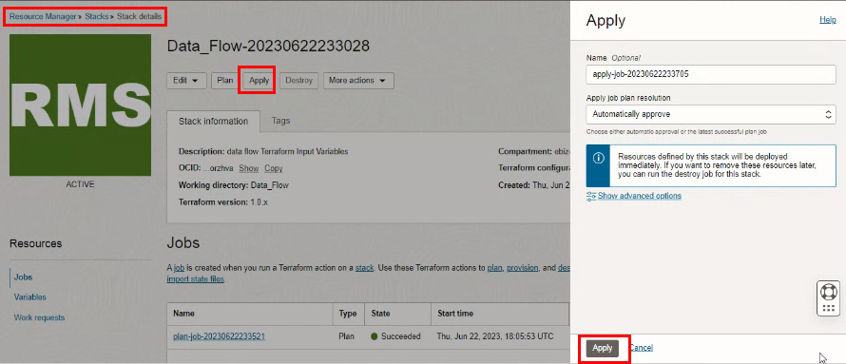

Verify the Apply is successful.
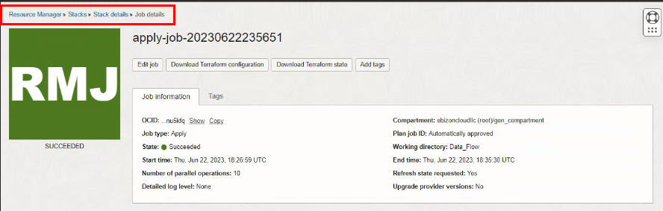

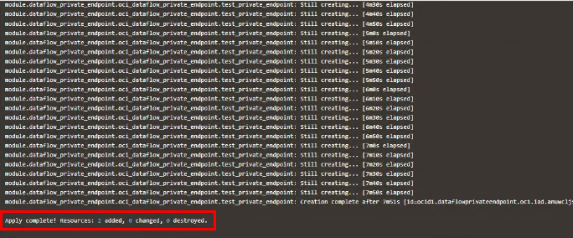

Verify in the Console

Go to OCI Console Analytics & AI Data LakeData flowApplications
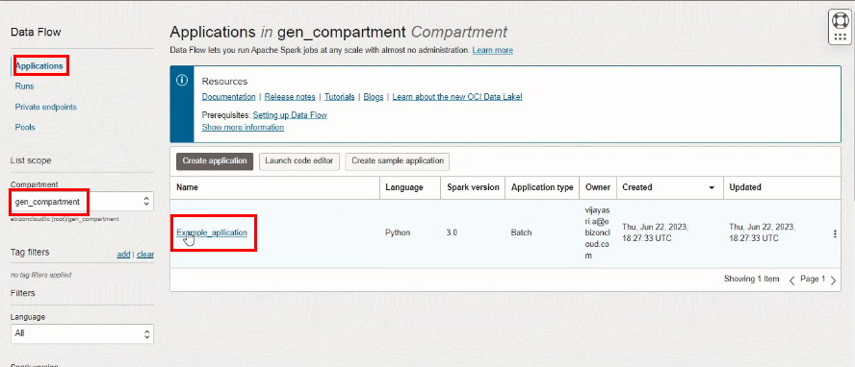

Go to OCI Console Analytics & AI Data LakeData flowApplication Details
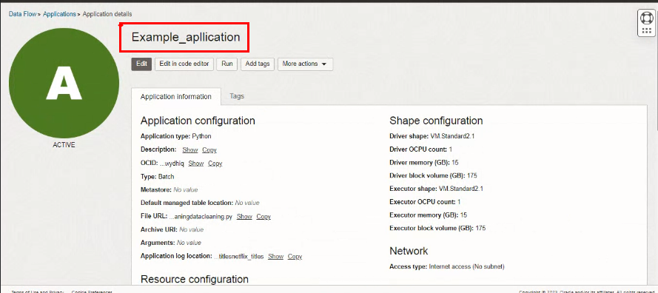

Go to OCI Console Analytics & AI Data LakeData flowPrivate Endpoints
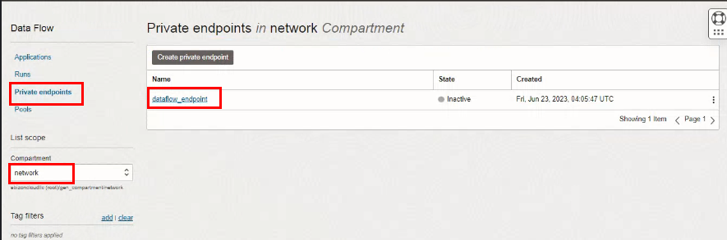

Destroy the stack

Create a destroy job in Resource Manager to release resources associated with a stack and clean up the tenancy. Once destroyed data cannot be recovered from resources.

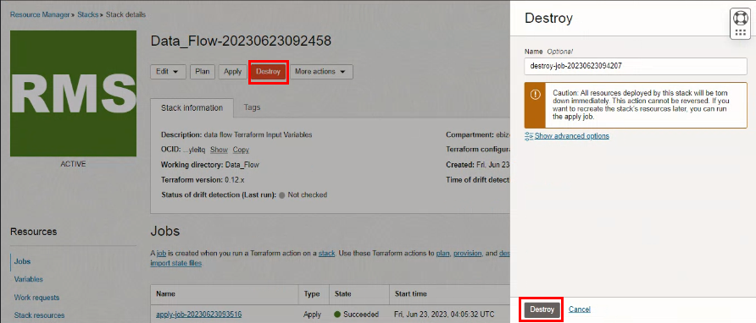

#END#

